2022 NoOneFightsAlone TOURNAMENT SHIRT PRE ORDERS
There will be limited amount at the tournament
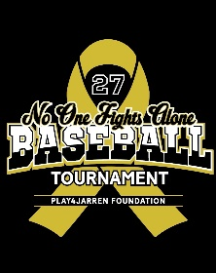
Shirt Front
NAME:_________________________________________________________________
TEAM NAME:____________________________________________________________
$15.00 - 50/50 Cotton Shirts
Youth S | Youth M | Youth L | Youth XL | Adult Small | Adult Med | Adult Large | Adult XL | Adult XXL | Adult  XXXL
$20.00 – Dry Fit
Youth S | Youth M | Youth L | Youth XL | Adult Small | Adult Med | Adult Large | Adult XL | Adult XXL | Adult  XXXL
$35- Crew Neck Sweatshirt
Youth S | Youth M | Youth L | Youth XL | Adult Small | Adult Med | Adult Large | Adult XL | Adult XXL | Adult  XXXL
$35 Hoodie Sweatshirt
Youth S | Youth M | Youth L | Youth XL | Adult Small | Adult Med | Adult Large | Adult XL | Adult XXL | Adult  XXXL

TOTAL DUE: ___________________________________________
ORDER DUE DATE: Wednesday Sept 11, 2022
You can order online at Play4Jarren.org or Send orders to: Kimcharlton1@hotmail.com

